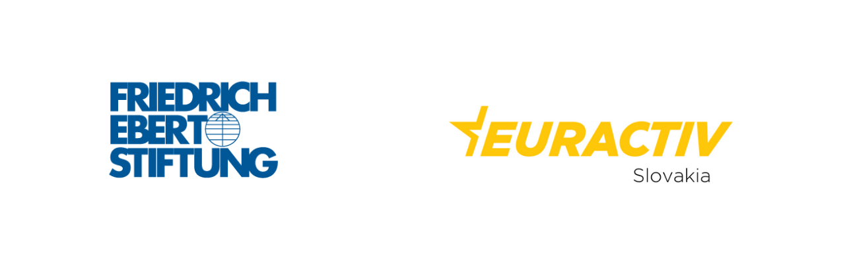
Bratislava Office of Friedrich-Ebert-Stiftung and the Euractiv invite You to an online event titled "Arms Control Post-Pandemics: Start of the New Arms Race?", which will be held on November 11, 2020 starting at 10:00 AM CET. Event will be held via Zoom.
Both panel discussions will be held in English. Simultaneouos interpretation will not be available.
URBAN ÜBERSCHÄR
Director for Czech Republic and Slovakia, Friedrich-Ebert-Stiftung
In the midst of the pandemic, several crucial arms control pursuits have been postponed, including the 10th Review Conference for the nuclear Non-Proliferation Treaty (NPT). But many keep on being at the centre of the attention. The New Strategic Arms Reduction Treaty (START) expires in 2021 and experts are already warning of potential arms race.
At the background, the indications of increasing budgets appear not only in the U.S. and Russia, but also in other countries, including China and India. For the first time in over 40 years, the world is facing the long-forgotten security risk: no arms control regime with a potential of arms proliferation.
AMBASSADOR RÜDIGER BOHN
Deputy Federal Government Commissioner for Disarmament and Arms Control, German Federal Foreign Ministry
ALICIA SANDERS-ZAKRE
Policy and Research Coordinator, International Campaign to Abolish Nuclear Weapons
TYTTI ERASTÖ
Senior Researcher, SIPRI Nuclear Disarmament, Arms Control and Non-Proliferation Programme
RALUCA CSERNATONI
Visiting Researcher, Carnegie Europe

Conventional arms control is politically and militarily relevant also for Central Europe and Slovakia. Although for Slovakia, arms proliferation and their control seem to be faraway matters, the security implications are beyond relevant. With the new government in Bratislava, strongly supporting NATO's crucial role in defense and security, it is, however, not clear, what arms control solution or type of a dialogue with relevant actors it prefers.
Although a number of past declarations to uphold international initiatives aimed at preventing the illegal acquisition of hazardous materials and goods or export control of military products, including guns, were agreed upon, stepping beyond proclamations is lagging. In the context of the enlarging attempts for European strategic autonomy, many new waters will have to be explored.
TOMÁŠ A. NAGY
Ministry of Defense of the Slovak Republic
RASTISLAV KRIŽAN
Ministry of Foreign and European Affairs of the Slovak Republic
MIKULÁŠ TURNER
Nuclear Regulatory Authority of the Slovak Republic

